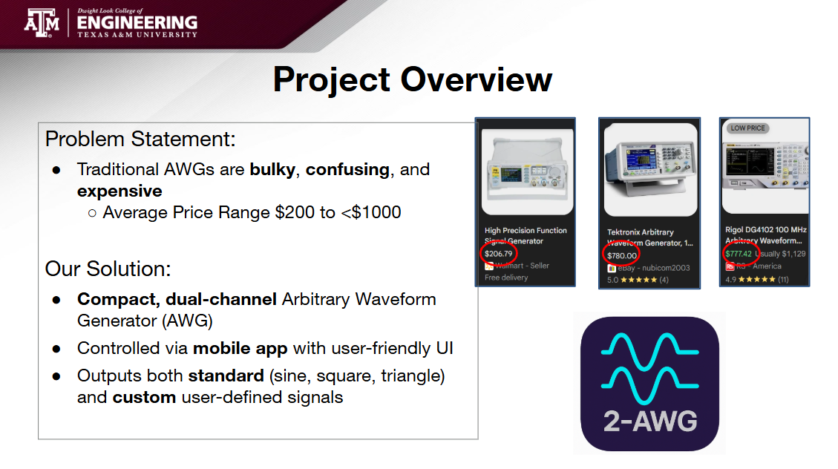

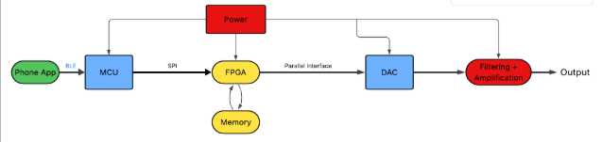
1minute above

Talk about role/validated line items in project
- Mobile- 1 min
- MCU- 1 min
- FPGA- 1 min
- Filter/Power- 1.5-2 min

Full System Demo- Rest is Demonstration
- Frequency
- Amplitude
- Offset
- All standard waveforms
- All Arbitrary waveforms

Q/A- leftover

